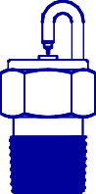
ATOMIZING
SYSTEMS INC
1140 Oak Road Manasquan, NJ 08736

T: +1-646.265.3826
E: JLeonard@pennvint.com

Manufacturers of COLD FOG Systems
Information Brochure* COLD FOG
HPV – Hydrogen Peroxide Fog System
Atomizing Systems' presents Decontamination System.
A totally self-contained. ULV (ultra low volume) fogging system that siphons hydrogen peroxide solution from any source to disinfect rooms, waiting rooms and high traffic problem areas.

    - Air Atomizing fog
    - Disperse fine fog into open rooms, corridors, air ducts, etc
    - Adjustable Flow Control
    - Single or multiple nozzle units available
    - Uses water-based systems
    - Electronic intermittent timer for ON/OFF all day use!
    - Low chemical consumption
    - Built in air-compressor
    - Industrial Grade
    - Quiet
    - Rated for over 14,000 hours continuous operation

Atomizing Systems' sanitation and odor-control systems now make the working
environment easier to work in for employees and neighbors!

ATOMIZING SYSTEMS - A TRUE INDUSTRIAL-QUALITY, CHEMICAL
FOG SYSTEM FOR DISINFECTION, ODOR-CONTROL AND PESTICIDE PRODUCTS

Weight: 17 pounds(7.7kg) Electrical: 115or220vac, 50/60Hz 3to5amps
Dimensions: 15.5 inches (39.3cm) L
7.125 (18cm) W
10.438 (26.5cm) H
Flow: .1 to .5GPH (.3 to l .8LPH)
Material: Aluminum on rubber feet

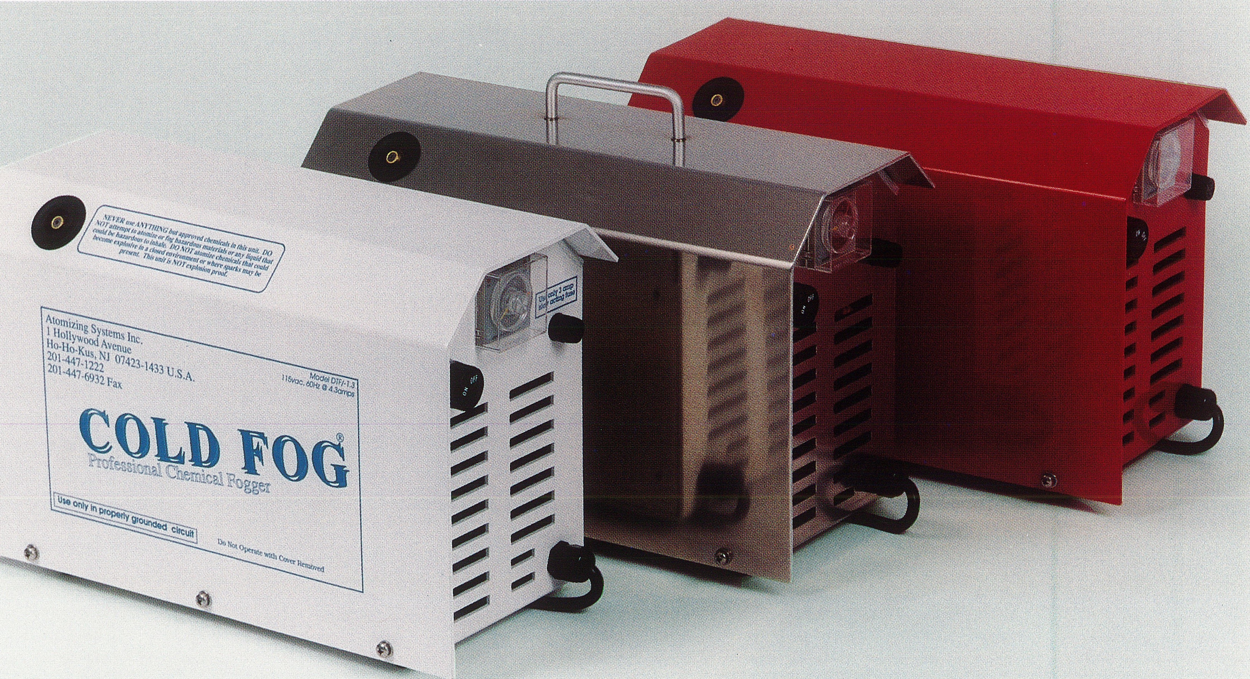

OPTIONS: Electronic Timer, Handle, Tamper-Proof Screws, Remote nozzle for ducts & through walls, hi-output compressor

ATOMIZING SYSTEMS INC. ■ l Hollywood Aven ue ■ Ho-Ho-Kus, NJ ■ 07423 USA ■

Contact:

1140 Oak Road Manasquan, NJ 08736

T: +1-646.265.3826
E: JLeonard@pennvint.com

It is reasonably understood that the COLDFOG system will have a high efficacy as a virucidal against the SARS-CoV-2, however general tests on this particular virus are just recently being conducted.

