
ATOMIZING
SYSTEMS INC
1140 Oak Road Manasquan, NJ 08736

Manufacturers of COLD FOG Systems T: +1-646.265.3826 E: JLeonard@pennvint.com
®
Information Brochure COLD FOG
HPV - Hydrogen Peroxide Fog
N95 & PPE Disinfection System

COLD FOG HPV – All stainless steel, 120vac fog-injection system for up to eight (maximum 40)
Fog Nozzles to inject Hydrogen Peroxide solution(s), based on time for:
N95 recycling, hospital rooms, ER’s, hospital tents, patient rooms, ambulances, first responder vehicles, classrooms, school bus interiors, etc.
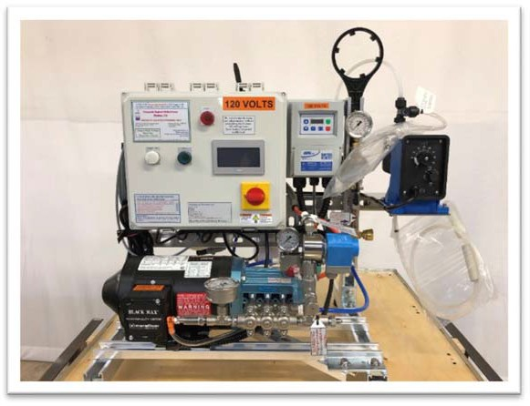
Cold Fog HPV -‘CF’-3 Typical Pump Skid X 120vac w/VFD
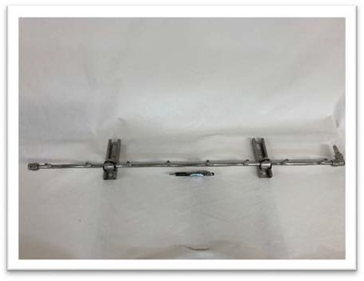
Actual 42” COLD FOG® Nozzle Manifold w/8 Nozzles

Fog activation started via electronic, off-delay countdown pushbutton timer by site operator.
Main feed hose, nozzle manifold, nozzles, fog pump, injection-pump (0- 6-GPD) & tripod are included within scope. Electronics are UL Labeled by ASI

- SCOPE OF SUPPLY: each system contains;
(1) Tripod, Industrial Berlebach B14112 Report Wood Tripod
(1) 316SS manifolds, 8 nozzle-risers per each ½” OD SS vertical tube @ ±42in
(1) SS Manifold Fittings (pre-assembled w/nozzles & JIC Connector)
- *Interconnecting High-pressure Water feed line @ 40ft X 1/8” ID SS with
- Swagelok SS Swivel Fittings, all 316 stainless steel

SCOPE OF MATERIALS & UTILITIES TO BE PROVIDED BY OTHERS

  - SANITATION CHEMICALS: Active Ingredients: Hydrogen Peroxide & Peroxyacetic Acid

Recommended Product: Sanidate 5.0
BioSafety Systems - East Hartford Connecticut.
EPA approved
Approved for H1N1 / Avian / SARS

POTABLE WATER:
Required; domestic water at minimum inlet pressure of 25PSI Recommended: clean, low-mineral content water
Sanitary Hose and Connection included

POWER SUPPLY:
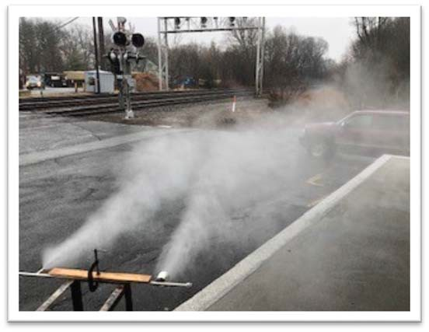
120V Outlet

Typical fog demonstration at 1,000PSI

APPLICATIONS

  - CURRENT PROJECT: Community Medical Facilities in Fresno, CA conducting SANITATION TESTS FOR SANITIZING N95 MASKS. Trial started 3/29.
  - SANITATION CORRIDORS: DISINFECTON / MITIGATION
Installed in tented corridors for staff and patients to decontaminate biological contaminants including SARS-CoV-2.

HOME & OFFICE SANITATION: Sanitize all surfaces at home and in office locations

It is reasonably understood that the COLDFOG CF-3 system will have a high efficacy as a virucidal against the SARS-CoV-2, however general tests on this particular
virus are just recently being conducted.

CONTACT: Sales Representative
John Leonard
E: JLeonard@pennvint.com
T: 646.265.3826

Cold Fog is a registered Trademark of Atomizing Systems Inc.
…long lasting, quiet fog systems worldwide since 1979

